**Experiment Procedure Documentation:**

**Instructions**

1. To run the experiment, simply run the Mass_Spectro_proj.html file by clicking on it and the experiment will open in the browser.

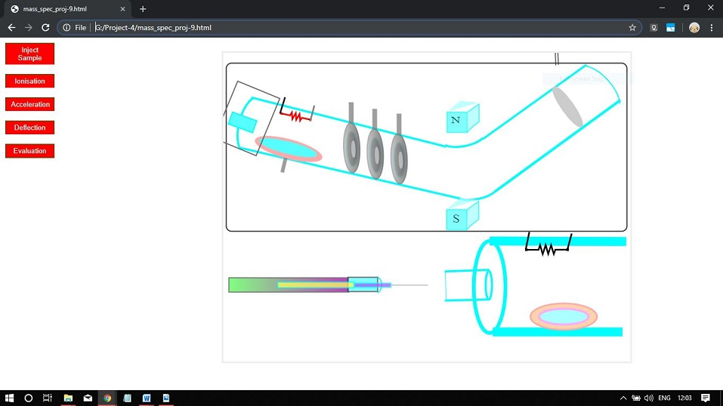

2. To run the experiment of Mass Spectroscopy, click on the “Inject Sample” button. After clicking on the ‘Inject Sample” button, this will appear.

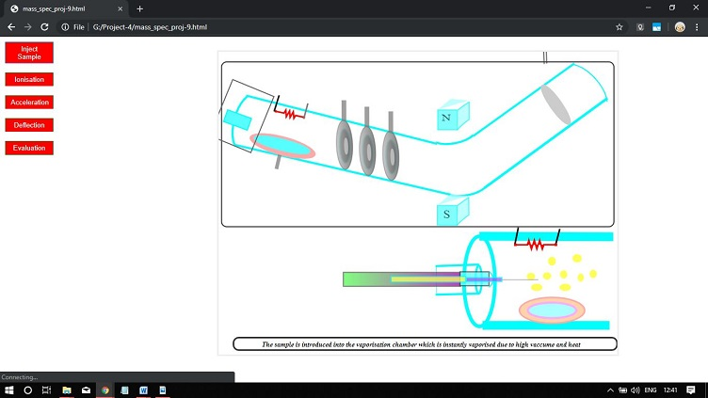

1. After completion of the various animation the next procedure is initiated by pressing the button marked ”Ionization”.

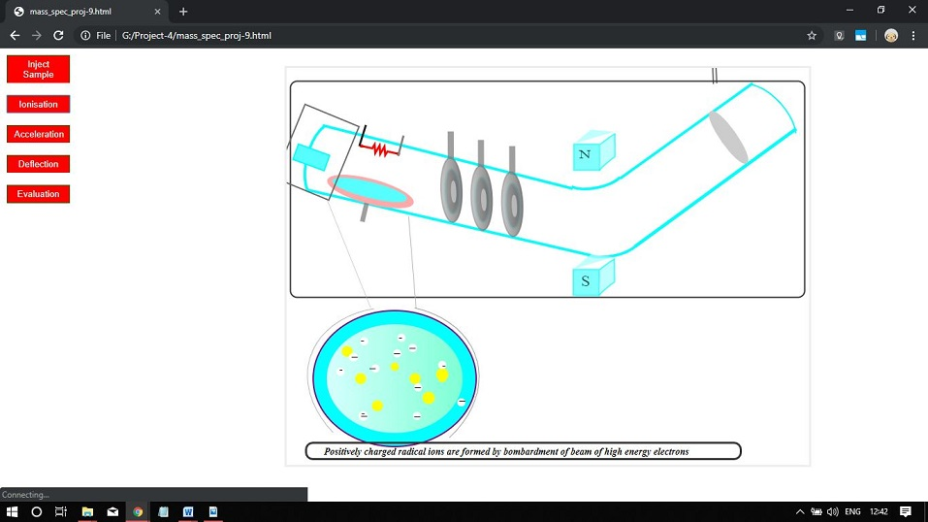

1. After completion of the various animations the next procedure is initiated by pressing the button marked ”Acceleration”.

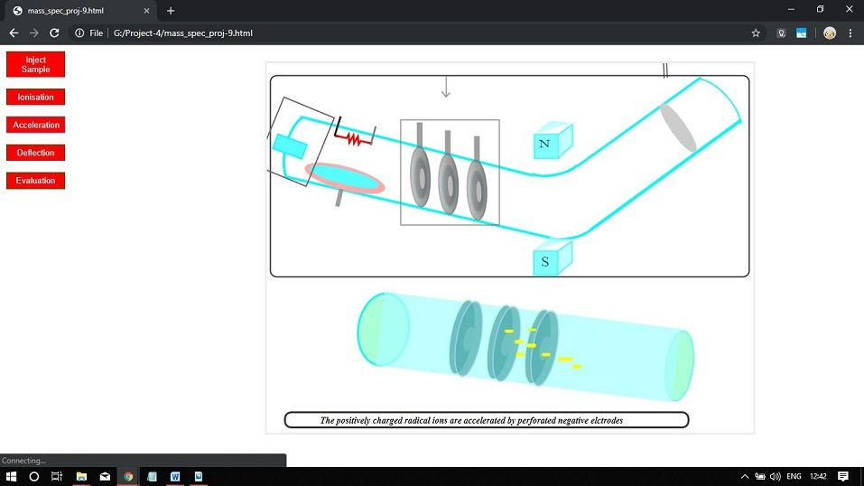

1. After completion of the various animations the next procedure is initiated by pressing the button marked ”Deflection”.

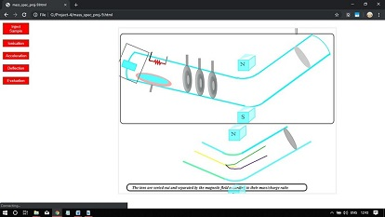

1. After completion of the various animations the next procedure is initiated by pressing the button marked ”Evaluation”.

7. The “Evaluation” button click results in opening of a new page which draws a graph based on data, provides a calculator for simple calculations and also provides form with input to submit the Evaluation Results.

